The website transfer is now complete. The major points to cover are:
- All of the site is now being served through SSL (meaning that it will default to https),
  - Specifically, the site is being served via TLS 1.2 to Cloudflare, then Cloudflare serves via TLS 1.3,
  - 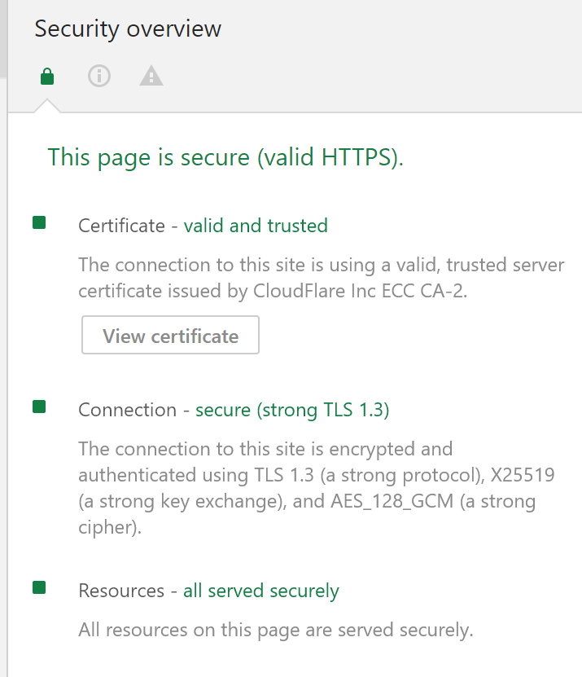
- Webmail is viewable via mail.tricitiespride.ca,
  - Calendars through calendar.tricitiespride.ca
- We can backup the site whenever we want.
I have also fully integrated GSuite with our webservices. Information on that is being distributed separately.

